North Grenville Curling Club Announcements
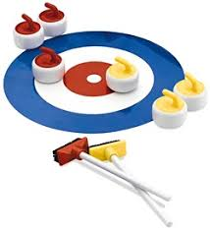
Fellow eQuinelle Residents
Although you can't tell by the weather, golf season will come to an end and will soon give way to curling!
If you are in the minority who stays around to enjoy our Canadian winters and are looking to keep active in a social environment, you may want to consider curling.
The North Grenville Curling Club will host an Open House
on Thursday, September 6th from 7:00 - 9:00 p.m.
and will also be open for Enquiries and Registration
on Saturday, September 8th from 10:00 a.m. to 12 noon.

Why not drop in to check out the club and learn about the various leagues as well as our friendly introduction to curling program.
No matter your skills, fitness level, or age, curling can be enjoyed by everyone: in fact, our club may hold a coveted record as our most experienced curler continues to play hard well into her nineties!
Club members will be happy to show you around, answer questions and maybe even share a beverage.
The curling club is located at 200 Reuben Crescent in Old Town Kemptville.

We hope to see you there but don't hesitate to let us know if you have any questions beforehand.
Mitch Barsalou & Barb Brown

